

DESIGN LAB PROJECT

HAND GESTURE CONTROLLED MECHANICAL ARM

Presented by: Submitted to:

Ankur Singh (2022MEB1298) Dr. Prabhat K. Agnihotri Sir

Arnav Maitreya (2022MEB1299) Dr. Manish Agrawal Sir

Aryan Daga (2022ME1300) Dr. Satwinder J Singh Sir

Priyanshu Singh(2022MEB1332)

Rahul Meena (2022MEB1333)

Date of submission – 26/04/2024

TABLE OF CONTENTS

* Introduction…………………………….………………………………………………….3
* Components Used……………………………………………………………………….4
* Construction………………………………………………………………………………4-6
* Working Principle………………………………………………………………………….6
* Testing & Calibration…………………………………………………………………….6
* Application…………………………………………………………………………………….7
* Contribution made by each student…………………………………………….7-8
* Conclusion…………………………………………………………………………………….9
* Acknowledgement………………………………………………………………………….9

INTRODUCTION

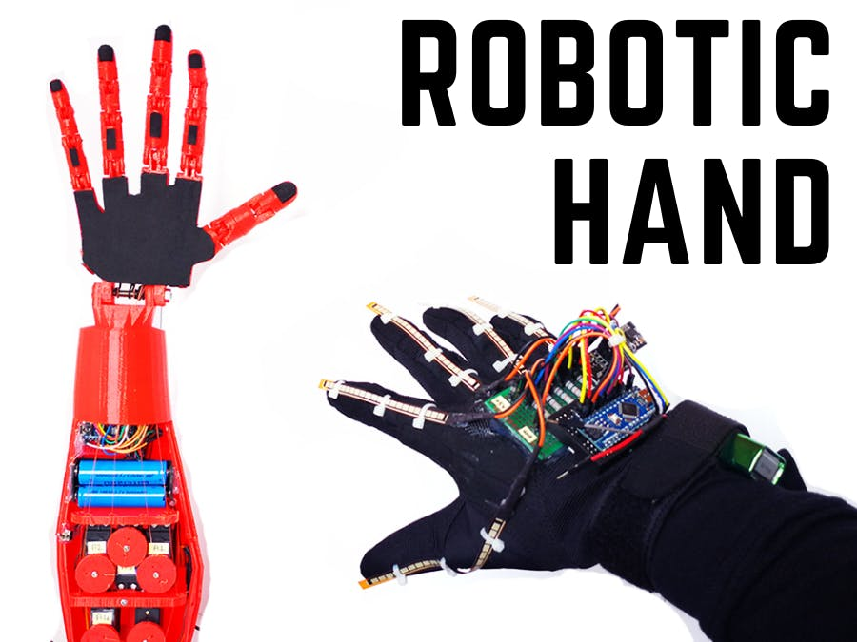

The project titled "Hand Gesture Controlled Robotic Arm" aims to create a robotic arm capable of mimicking the movements of a human hand based on hand gestures. This report outlines the components used and the construction process of the robotic arm. The project utilizes a combination of advanced technologies including ESP32 microcontroller, flex sensors, and servo motors to achieve precise control over the robotic arm's movements. The primary objective of this project is to demonstrate a hands-free control mechanism for robotic manipulation, which can find applications in various fields such as manufacturing, healthcare, and assistive technology.

COMPONENTS USED

* **5 Flex sensors:** Detects finger bending and generates analog signals.
* **5 Servo motors:** Actuates the fingers of the robotic hand.
* **Arduino UNO board:** map the flex sensor data and send it to ESP32 connected to it.
* **Microcontroller (ESP32):** Interprets Arduino data and accordingly controls servo motors.
* **Connection pins:** To connect the flex sensors, servo motors and microcontrollers to breadboard.
* **Springs:** To bend the robotic hand according to flex sensors.
* **3D printer:** To 3D print the model of hand made on Solid works.
* **Mechanical framework:** Provides structure for the robotic hand.
* **Power supply:** Provides electrical power to servo motors.

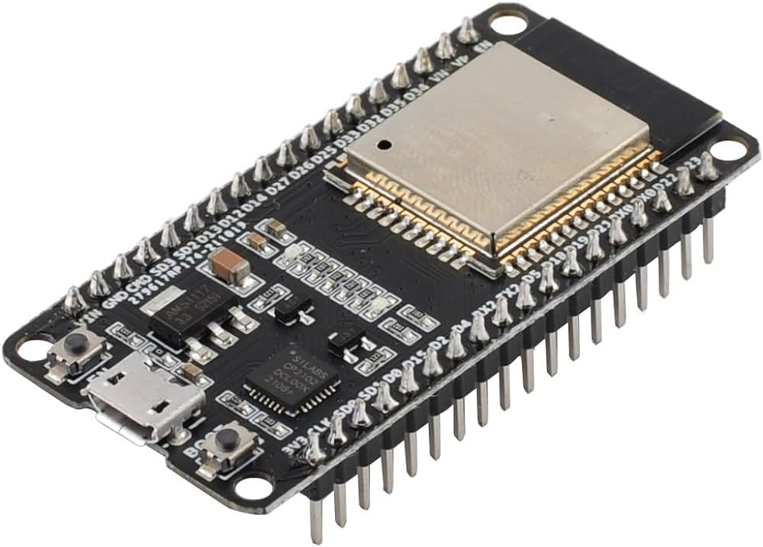 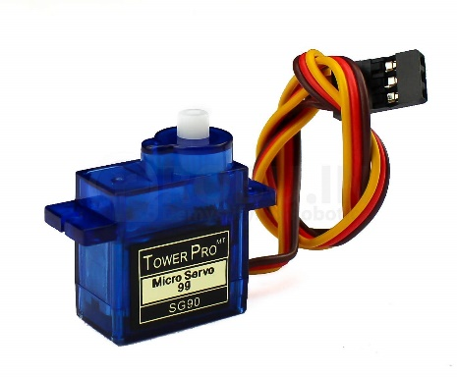

CONSTRUCTION

The construction of the hand gesture controlled robotic arm involved two main components: the printed robotic arm and the glove with flex sensors.

Printed Robotic Arm :

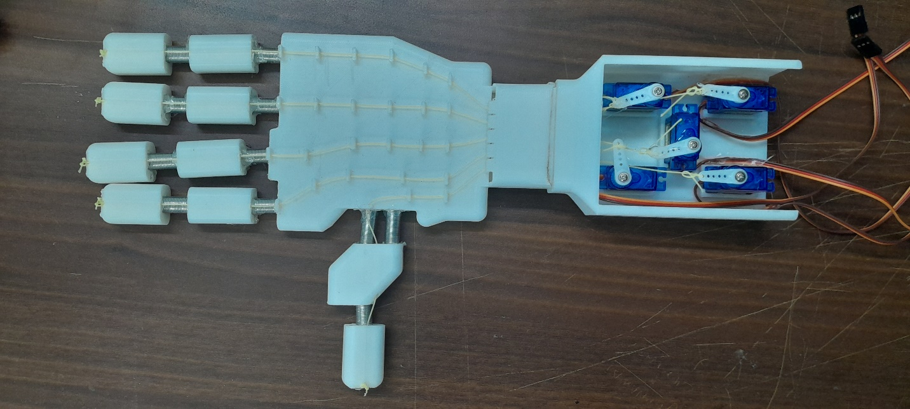

* The robotic arm was designed using SolidWorks and then printed using a 3D printer.
* Each finger of the robotic hand was printed in two parts and connected using springs to replicate the movement of actual fingers.
* 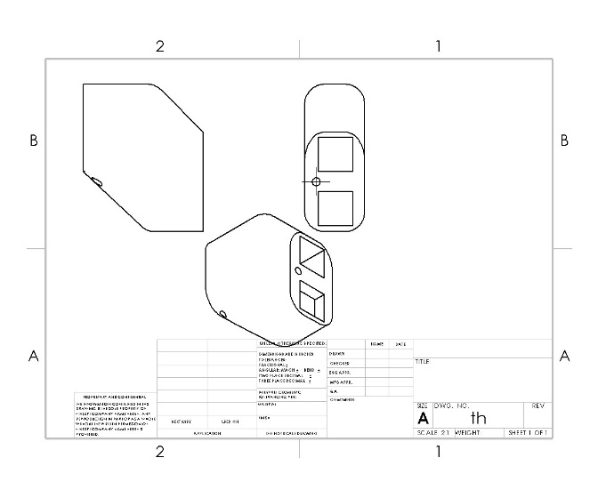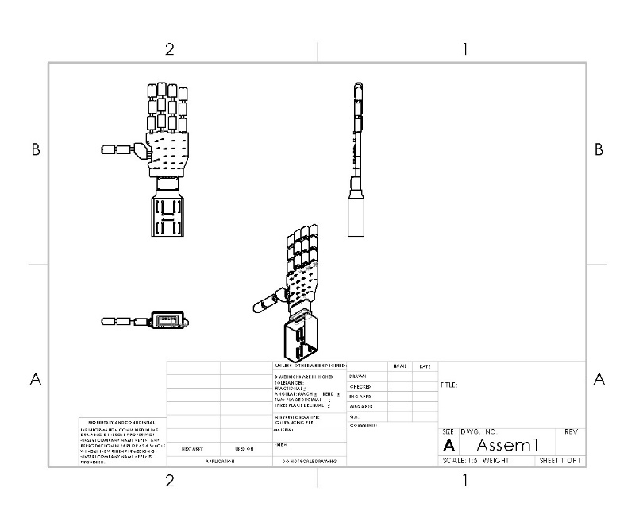Nylon strings were used, passing through small holes in the finger parts and connected to servo motors. These servo motors controlled the movement of the fingers.

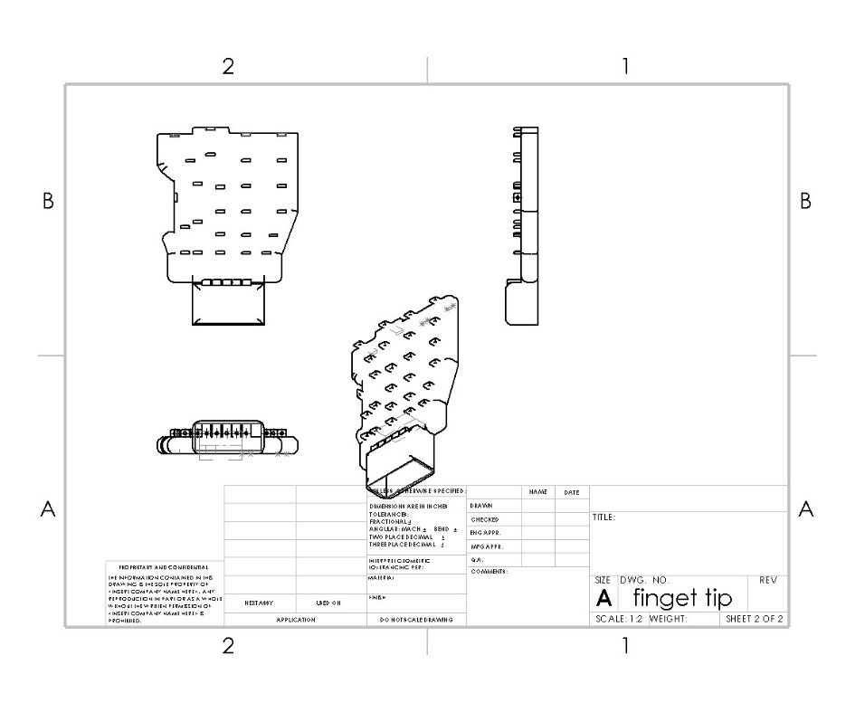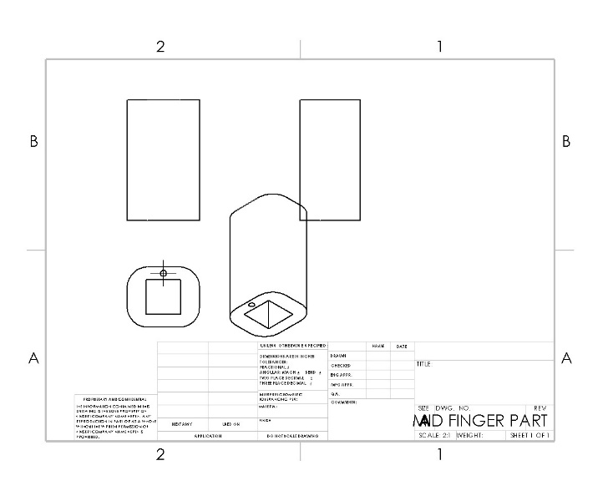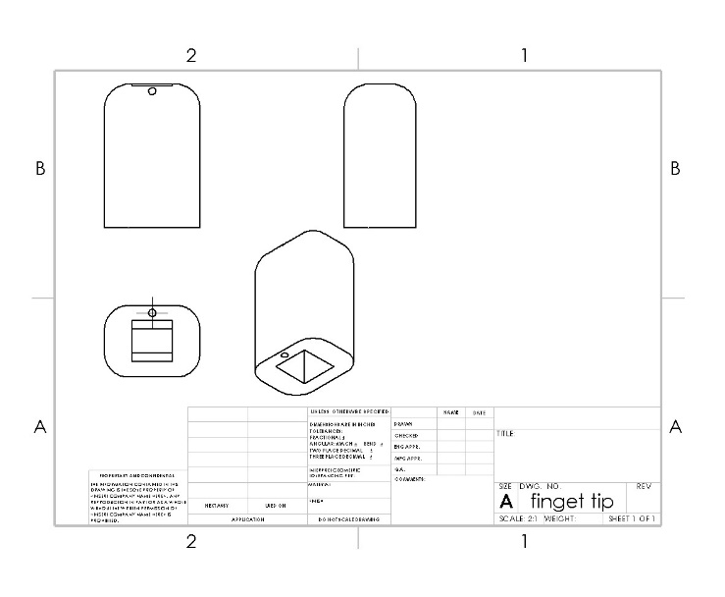

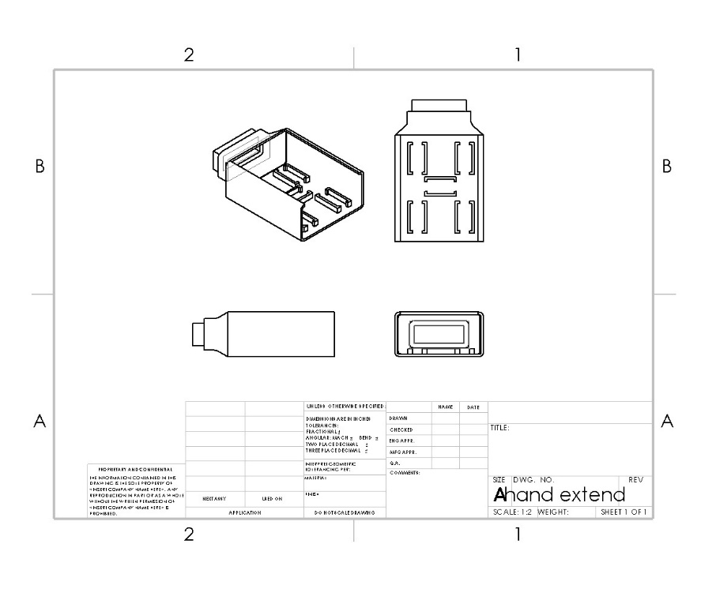

Glove with Flex Sensors:



* A glove was designed with flex sensors attached to each finger.
* Flex sensors were connected to a breadboard, which was then connected to an Arduino UNO board for data collection.
* Data collected from the flex sensors was transmitted via wires to one ESP board.
* 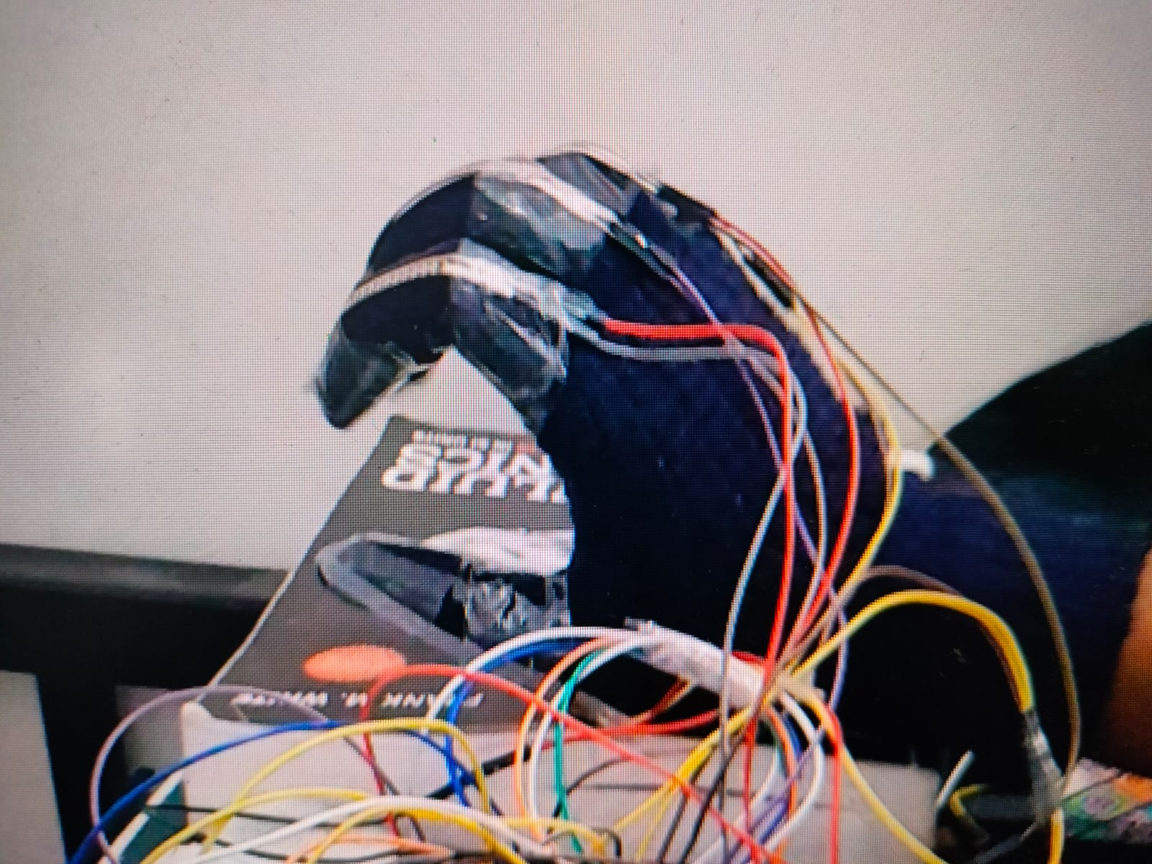The ESP board transmitted this data wirelessly to another ESP board, which controlled the servo motors of the robotic arm.

WORKING PRINCIPLE

* When the user wears the glove and moves their fingers, the flex sensors detect the movement and send analog data to the Arduino UNO board.
* The Arduino UNO board processes this data and transmits it via wired connection to one ESP board in real-time.
* The ESP board wirelessly transmits this data to another ESP board connected to the servo motors.
* The servo motors receive the data and rotate, pulling the nylon strings connected to the robotic fingers.
* As a result, the robotic fingers mimic the movement of the user's fingers, thus achieving the desired hand gestured control of the robotic arm.

TESTING AND CALIBRATION

* We calibrate the flex sensors to ensure accurate measurement of finger movements.
* Tested the robotic hand with various hand gestures to verify the accuracy and responsiveness of the control system.
* We Fine-tune the control algorithm to optimize the performance of the robotic hand.

APPLICATIONS

**Manufacturing Automation:** The hand-controlled robotic arm can be used in manufacturing industries for tasks such as assembly, pick-and-place operations, and quality inspection.

**Rehabilitation and Healthcare:** This technology can assist individuals with physical disabilities in performing daily tasks and rehabilitation exercises.

**Education and Research:** The project can serve as an educational tool for learning about robotics, embedded systems, and sensor interfacing. It also offers opportunities for research in human-machine interaction and gesture recognition.

CONTRIBUTION BY EACH STUDENT

**1. Ankur Singh (2022meb1298):**

Ankur focused on the programming and communication aspects of the project. wrote code for the Arduino UNO board to process data from the flex sensors and transmit it to the ESP boards. Ankur also worked on establishing wireless communication between the ESP boards and troubleshooting any issues related to data transmission.

**2. Arnav Maitreya (2022meb1299):**

Arnav focused on programming and development of the glove with flex sensors, a pivotal component of the project. He led the implementation of flex sensors on the glove and their connection to the Arduino UNO board for data collection. Also, Arnav contributed to design the robotic arm on SolidWorks.

**3. Aryan Daga (2022meb1300):**

Aryan was instrumental in the electrical aspects of the project. He worked on configuring the connections between the Arduino UNO board, flex sensors, and ESP boards for data transmission. Aryan also contributed to the power supply setup for the servo motors, ensuring they received adequate power for smooth operation along with assembly of robotic arm structure.

**4. Priyanshu Singh (2022meb1332):**

Priyanshu played a crucial role in the design and construction phase of the project. Additionally, Priyanshu contributed to the assembly of the robotic fingers and the integration of servo motors with the nylon strings for finger movement. Also, Priyanshu contributed to the preparation of presentation.

**5. Rahul Meena (2022meb1333):**

Rahul played a crucial role in the overall coordination and documentation of the project. He contributed in construction of project and assembly of robotic arm. Rahul also contributed to the preparation of the project report, ensuring that all details were accurately documented and presented.

Each member's contribution was integral to the successful completion of the hand gestured robotic arm project, highlighting the effectiveness of teamwork and collaboration in achieving complex engineering goals.

PROBLEMS FACED

* **Issues with manufacturing and design** — We had intended for the finger to have three sections with three springs each to simulate joints, but we had to reduce the number of parts to two with two joints because the model was unstable and wobbled a lot. Additionally, there were certain dimensional and design errors that could have happened while creating a CAD model or while 3D printing, but they were fixed by a variety of manufacturing techniques like filling and milling.
* **Data transmission** – Initially, we intended to use the Arduino Uno along with nrf24l01 for connectivity but we were given esp32 microcontroller's which have built-in wi-fi and Bluetooth connectivity function to send real-time data wirelessly. However, we soon discovered that wi-fi signals are interfering with the analog data we are configuring from the flex sensor, which resulted in no change or garbage value in the sent data.   
  The issue was fixed by reading the analog data using a separate microcontroller (an Arduino Uno), sending it to an esp32 module via a connected connection, and then sending it wirelessly to another esp32 module.
* **Inefficient output –** Flex sensor is very sensitive to it gives range of values at a single state, additionally due to continuous testing the sensitivity of sensor changes drastically such that it gives completely different range of values from before which may have been due to strain occurring because of the continuous bending or heating effect on resistance due to long duration of testing.

Due to this issue we need to change mapping of values of flex sensor frequently according to changes in sensitivity of sensor which is nearly impossible hence output gets changed frequently in small amount of time.

CONCLUSION

We were able to move each finger at about 130 degrees using the servo motors with respect to the data which we obtained from the flex sensors. At last, our project was working which can also be seen in video attached in our presentation. The overall working code’s logic and syntax was written by us only the wi-fi connectivity part was coded by taking the help from the official site of esp32 controller –

<https://www.espressif.com/en/hidden/support/explore/sample-codes>

Also, the 3D model of the mechanical arm is totally designed by us.

The hand gestured mechanical arm project successfully demonstrates the integration of flex sensors, Arduino boards, ESP boards, servo motors, and 3D printing technology to create a mechanical robotic arm controlled by hand gestures. This project showcases the potential applications of fabrication of robotics in industries where precise and intuitive control mechanisms are required.

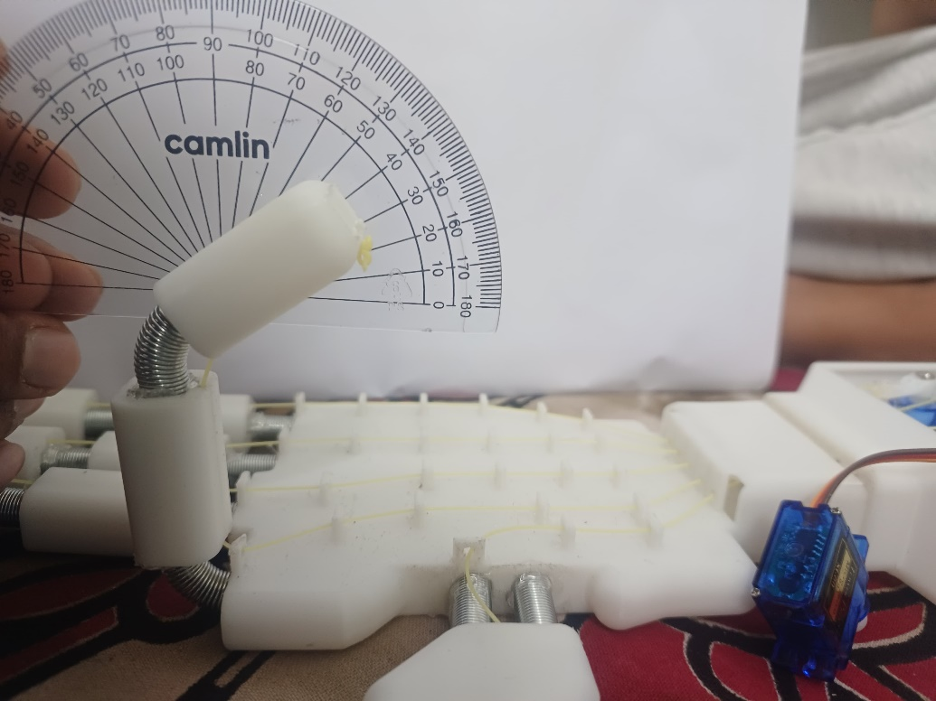

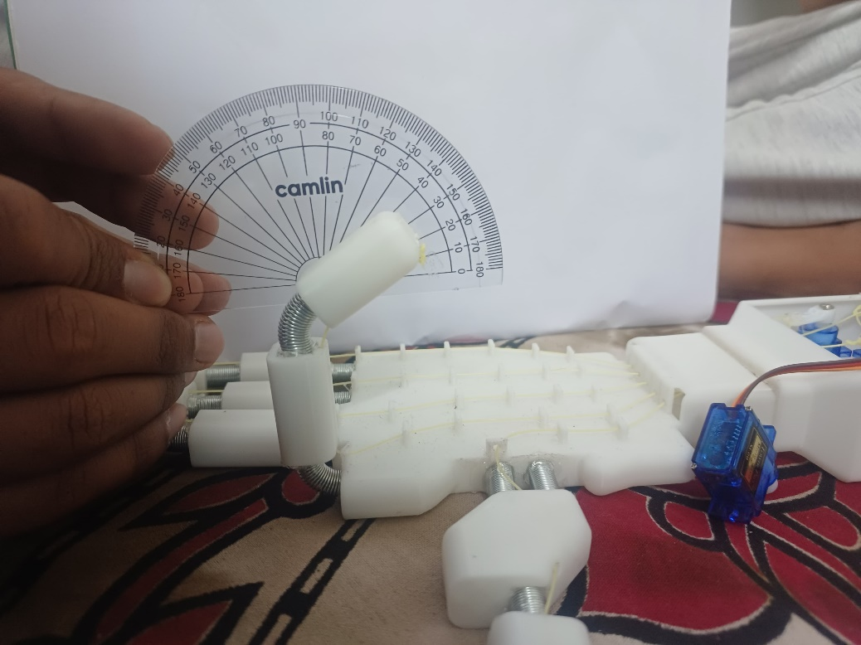

ACKNOWLEDGMENTS

We would like to express our gratitude to our project guide and all those who supported us throughout the development of this project.